**Eaton Guide Specification**

**Notes and instructions to specwriter**

The following guide specification is offered for your assistance in specifying this product as part of a CSI (Construction Specification Institute) compliant document.

This guide specification has been created in MS Word and uses Word features including **Styles** and **Review** to assist in editing and formatting. You may also find it helpful to view the document in **Outline** mode when editing or selecting sections to copy/paste into your base document.

**Styles**

Styles are provided for all paragraph types described in the CSI Masterformat. Applying a Style to text will provide the correct indentation, paragraph letter/number, font, capitalization, etc…. Styles are shown on the right-hand side of the Word “Home” ribbon.

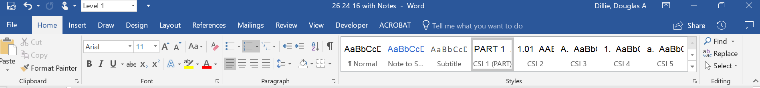

**Review**

“Notes to Specwriter” (when available) are provided using the Reviews feature in Word. To view “Notes to Specwriter” select “All Markup” in the Tracking dropdown menu on the Review ribbon. To hide notes, select “No Markup”. You can advance from one note to the next using the Previous and Next buttons on the same ribbon. In earlier versions of MSWord hide notes by un-checking ‘Comments’ under Review>SH

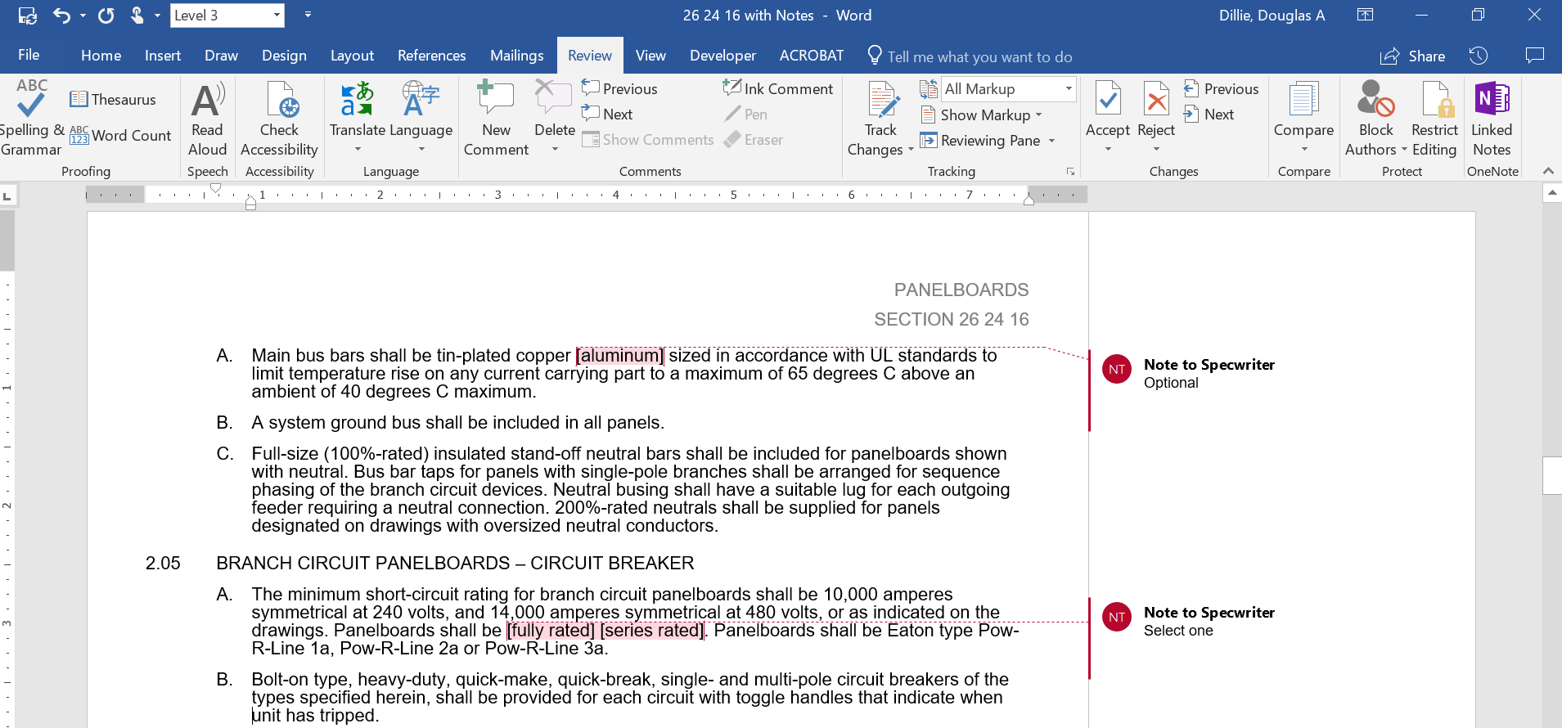

**Outline view**

The Outline view within Word is often helpful when editing or copying sections from this Guide Specification. Also, when pasting sections from this document into a base document the specwriter may want to consider using right-click and “Merge Formatting’ or ‘Keep Text Only” features.

Section 26 28 16.27

1000VDC safety Switches

# general

## Scope

### The Contractor shall furnish and install the low-voltage non-fusible switches as specified herein and as shown on the contract drawings.

## Related Sections

## References

### The switches and all components shall be designed, manufactured and tested in accordance with the latest applicable standards:

#### NEMA KS-1

#### UL 98B

## Submittals – for Review/approval

### The following information shall be submitted to the Engineer:

#### Dimensioned outline drawing

#### Conduit entry/exit locations

#### Switch ratings including:

##### Short-circuit rating

##### Voltage

##### Continuous current

#### Fuse ratings and type

#### Cable terminal sizes

#### Product data sheets

## Submittals – for construction

### The following information shall be submitted for record purposes:

#### Final as-built drawings and information for items listed in Paragraph 1.04, and shall incorporate all changes made during the manufacturing process

## Qualifications

### The manufacturer of the assembly shall be the manufacturer of the major components within the assembly.

### Provide Seismic tested equipment as follows:

#### The equipment and major components shall be suitable for and certified by actual seismic testing to meet all applicable seismic requirements of the [latest International Building Code (IBC)] [latest California Building Code (CBC) with OSHPD Amendments]. [The equipment shall have OSHPD Special Seismic Certification (OSP) Pre-Approval.]

#### The Project Structural Engineer will provide site specific ground motion criteria for use by the manufacturer to establish SDS values required.

#### The IP rating of the equipment shall be 1.5

#### The Structural Engineer for the Site will evaluate the SDS values published on the [Manufacturer’s] [OSHPD] website to ascertain that they are "equal to" or "greater than" those required for the Project Site.

#### The following minimum mounting and installation guidelines shall be met, unless specifically modified by the above referenced standards.

##### The Contractor shall provide equipment anchorage details, coordinated with the equipment mounting provision, prepared and stamped by a licensed civil engineer in the state. Mounting recommendations shall be provided by the manufacturer based upon the above criteriato verify the seismic design of the equipment.

##### The equipment manufacturer shall certify that the equipment can withstand, that is, function following the seismic event, including both vertical and lateral required response spectra as specified in above codes.

##### The equipment manufacturer shall document the requirements necessary for proper seismic mounting of the equipment. Seismic qualification shall be considered achieved when the capability of the equipment, meets or exceeds the specified response spectra.

## Regulatory Requirements

### The safety switches shall bear a UL label.

## Delivery, Storage and Handling

### Equipment shall be handled and stored in accordance with manufacturer’s instructions. One (1) copy of these instructions shall be included with the equipment at time of shipment.

# products

## manufacturers

### Eaton

### __________

### __________

The listing of specific manufacturers above does not imply acceptance of their products that do not meet the specified ratings, features and functions. Manufacturers listed above are not relieved from meeting these specifications in their entirety. Products in compliance with the specification and manufactured by others not named will be considered only if pre-approved by the Engineer ten (10) days prior to bid date.

## Solar Disconnect switches

### Provide 30- to 100-ampere switches as shown on the drawings for solar installations with the following ratings and characteristics:

#### Switches shall be UL 98B listed for 1000vDC, and shall be wired according to the listing instructions.

#### Switches shall not be polarity sensitive – must be capable of application in either positive grounded or negative grounded systems.

#### Switched shall be bi-directional in design. Shall use permanent magnets to stretch the arc and/or force arc movement, and be capable of extinguishing an arc in normal and reverse current flow.

#### Switches applied for an ungrounded system shall also be bi-directional devices.

#### NEMA enclosure shall be NEMA 3R, 4 or 4X as shown on the drawings.

#### Switches shall be listed as “Suitable for NEC Article 690 Applications” and shall be labeled with the maximum solar string Isc per NEC calculations.

#### Switches shall provide a visible means of disconnect, independent of the side operated handle. Trailing edge of blade must be viewable when handle is in the off position.

#### Switches that can be energized from both the line and load side shall be marked:

## WARNING

### ELECTRIC SHOCK HAZARD. DO NOT TOUCH TERMINALS. TERMINALS ON BOTH THE LINE AND LOAD SIDES MAY BE ENERGIZED IN THE OPEN POSITION.

#### Switches shall be supplied with a clear, factory-installed dead-front shield to guard against accidental contact with line or load terminals.

#### Non-fusible switches shall be suitable for use on a circuit capable of delivering up to 10,000A, 1000Vdc.

#### Switches shall have a factory-installed neutral block for terminating grounded conductorswhen applied on a grounded system.

#### Switches shall be installed with an equipment ground bar.

## NAMEPLATES

### Nameplate shall be front cover mounted, containing a permanent record of switch type, ampere rating, and maximum voltage rating.

# EXECUTION

## FACTORY TESTING

### Standard factory tests shall be performed on the equipment provided under this section. All tests shall be in accordance with the latest version of UL and NEMA standards.

## INSTALLATION

### The equipment shall be installed per the manufacturer’s recommendations and all NEC and local code requirements.