**Eaton Guide Specification**

**Notes and instructions to Specwriter**

The following guide specification is offered for your assistance in specifying this product as part of a CSI (Construction Specification Institute) compliant document.

This guide specification has been created in MS Word and uses Word features including **Styles** and **Review** to assist in editing and formatting. You may also find it helpful to view the document in **Outline** mode when editing or selecting sections to copy/paste into your base document.

**Styles**

Styles are provided for all paragraph types described in the CSI Masterformat. Applying a Style to text will provide the correct indentation, paragraph letter/number, font, capitalization, etc…. Styles are shown on the right-hand side of the Word “Home” ribbon.

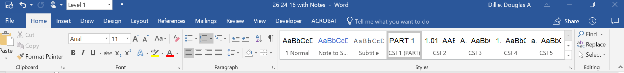

**Review**

“Notes to Specwriter” (when available) are provided using the Reviews feature in Word. To view “Notes to Specwriter” select “All Markup” in the Tracking dropdown menu on the Review ribbon. To hide notes, select “No Markup”. You can advance from one note to the next using the Previous and Next buttons on the same ribbon. In earlier versions of MSWord hide notes by un-checking ‘Comments’ under Review>SH

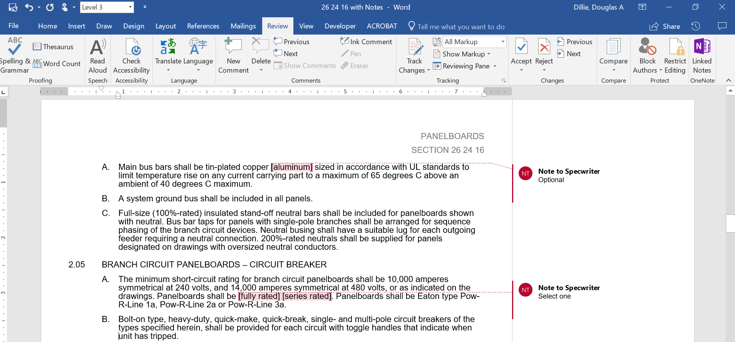

**Outline view**

The Outline view within Word is often helpful when editing or copying sections from this Guide Specification. Also, when pasting sections from this document into a base document the specwriter may want to consider using right-click and “Merge Formatting’ or ‘Keep Text Only” features.

section 26 27 00.11

MINI-POWER CENTERS

# General

## Scope

### The Contractor shall furnish and install single-phase and three-phase general purpose individually mounted mini-power centers of the two-winding type, self-cooled, as specified herein and as shown on the contract drawings.

## Related Sections

## References

### The mini-power center and all components shall be designed, manufactured and tested in accordance with the latest applicable standards of UL, ANSI and NEMA.

## Submittals – for review/approval

### The following information shall be submitted to the Engineer:

#### Dimension drawing weights

#### Transformer ratings including:

##### kVA

##### Primary and secondary voltage

##### Taps

##### Primary and secondary continuous current

##### Insulation class and temperature rise

##### Sound level

#### Component ratings including:

##### Voltage

##### Continuous current

##### Interrupting ratings

#### Cable terminal sizes

#### Product data sheets.

## Submittals – for construction

### The following information shall be submitted for record purposes:

#### Final (as-built) drawings and information for items listed in Paragraph 1.04, and shall incorporate all changes made during the manufacturing process

#### Connection diagrams

#### Installation information

## Qualifications

### The manufacturer of the assembly shall be the manufacturer of the secondary distribution equipment.

### For the equipment specified herein, the manufacturer shall be ISO 9001 or 9002 certified.

### The manufacturer of this equipment shall have produced similar electrical equipment for a minimum period of five (5) years.

## Regulatory Requirements

### The assembly and all components shall be U.L. listed.

## Delivery, Storage and Handling

### Equipment shall be handled and stored in accordance with manufacturer’s instructions. One (1) copy of these instructions shall be included with the equipment at time of shipment.

## Operation and Maintenance Manuals

### Equipment operation and maintenance manuals shall be provided with each assembly shipped, and shall include instruction leaflets and instruction bulletins for the complete assembly and each major component.

# products

## manufacturers

### Eaton

### __________

### __________

The listing of specific manufacturers above does not imply acceptance of their products that do not meet the specified ratings, features and functions. Manufacturers listed above are not relieved from meeting these specifications in their entirety. Products in compliance with the specification and manufactured by others not named will be considered only if pre-approved by the Engineer ten (10) days prior to bid date.

## ratings

### kVA and voltage ratings shall be as shown on the drawings.

### Units shall be designed for continuous operation at rated kVA, for 24 hours a day, 365 days a year operation, with normal life expectancy as defined in ANSI C57.96.

### Transformer sound levels shall not exceed the following ANSI and NEMA levels for self-cooled ratings:

### Up to 9 kVA 40 db 10 to 30 kVA 45 db

## construction

### Each mini-power center shall include a primary main breaker, an encapsulated dry-type transformer and a (loadcenter)(panelboard) with secondary main breaker.

### Primary main, secondary main and feeder breakers shall be enclosed with a padlockable hinged door.

### Mini-power centers shall be suitable for service entrance application and labeled as such.

### Insulation Systems

#### Transformers shall be insulated with a 180 degrees C insulation system and rated at 115 degrees C temperature rise

#### Required performance shall be obtained without exceeding the above-indicated temperature rise in a 40 degrees C maximum ambient, with a 30 degrees C average over 24 hours

#### All insulation materials shall be flame-retardant and shall not support combustion as defined in ASTM Standard Test Method D635

### Core and Coil Assemblies

#### Transformer core shall be constructed with high-grade, non-aging, silicon steel with high magnetic permeability, and low hysteresis and eddy current losses. Maximum magnetic flux densities shall be substantially below the saturation point. The transformer core volume shall allow efficient transformer operation at 10% above the nominal tap voltage. The core laminations shall be tightly clamped and compressed. Coils shall be wound of electrical grade aluminum [copper optional] with continuous wound construction.

#### The core and coil assembly shall be completely encapsulated in a proportioned mixture of resin and aggregate to provide a moisture proof, shock-resistant seal. The core and coil encapsulation system shall minimize the sound level.

#### The core of the transformer shall be grounded to the enclosure

#### Provide two (2) 5% FCBN taps

## bus

### Secondary bus shall be (aluminum)(copper).

## wiring/terminations

### All interconnecting wiring between the primary breaker and transformer, secondary main breaker and transformer and distribution section shall be factory installed.

### All transformers shall be equipped with a wiring compartment suitable for conduit entry and large enough to allow convenient wiring.

## Main devices

### Each mini-power center shall include a primary main breaker with an interrupting rating of (14 kA)(65kA) at 277/480 volts; and a secondary main breaker with an interrupting rating of 10kA at 120/240 volts, and a (loadcenter)(panelboard).

## feeder devices

### The secondary distribution section shall accommodate one-inch (plug-in breakers)(bolt-on breakers) with 10 kA interrupting capacity.

## Enclosure

### The enclosure shall be made of heavy-gauge steel and the maximum temperature of the enclosure shall not exceed 90 degrees C.

### The enclosure shall be totally enclosed, nonventilated, NEMA 3R, with lifting provisions.

# execution

## factory testing

### The following standard factory tests shall be performed on the equipment provided under this section. All tests shall be in accordance with the latest version of ANSI and NEMA.

#### Ratio tests at the rated voltage connection and at all tap connections

#### Polarity and phase-relation tests on the rated voltage connection

#### Applied potential tests

#### Induced potential test

#### No-load and excitation current at rated voltage on the rated voltage connection

## installation

### The Contractors shall install all equipment per the manufacturer’s recommendations and the contract drawings.

## field adjustments

### Adjust taps to deliver appropriate secondary voltage.

## field testing

### Measure primary and secondary voltages for proper tap settings.