**Eaton Guide Specification**

**Notes and instructions to Specwriter**

The following guide specification is offered for your assistance in specifying this product as part of a CSI (Construction Specification Institute) compliant document.

This guide specification has been created in MS Word and uses Word features including **Styles** and **Review** to assist in editing and formatting. You may also find it helpful to view the document in **Outline** mode when editing or selecting sections to copy/paste into your base document.

**Styles**

Styles are provided for all paragraph types described in the CSI Masterformat. Applying a Style to text will provide the correct indentation, paragraph letter/number, font, capitalization, etc…. Styles are shown on the right-hand side of the Word “Home” ribbon.

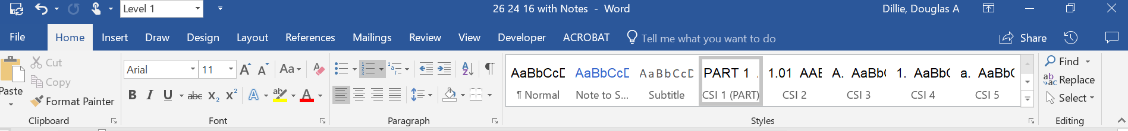

**Review**

“Notes to Specwriter” (when available) are provided using the Reviews feature in Word. To view “Notes to Specwriter” select “All Markup” in the Tracking dropdown menu on the Review ribbon. To hide notes, select “No Markup”. You can advance from one note to the next using the Previous and Next buttons on the same ribbon. In earlier versions of MSWord hide notes by un-checking ‘Comments’ under Review>SH

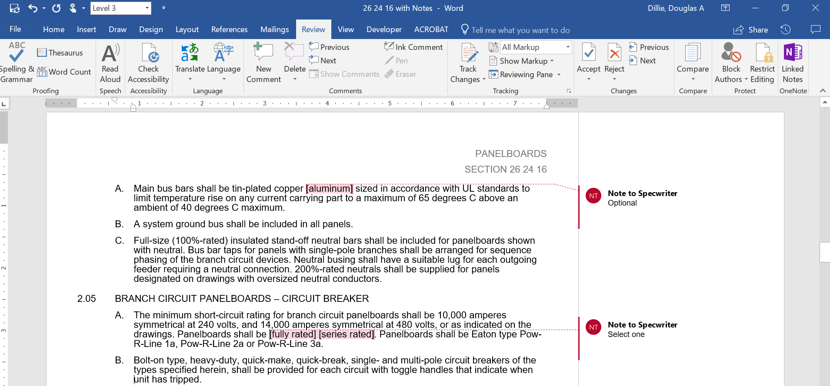

**Outline view**

The Outline view within Word is often helpful when editing or copying sections from this Guide Specification. Also, when pasting sections from this document into a base document the specwriter may want to consider using right-click and “Merge Formatting’ or ‘Keep Text Only” features.

SEction 26 24 16.11

lighting control panelboard

# general

## Scope

### The Contractor shall furnish and install Lighting Control Panelboards as specified and as shown on the contract drawings.

### The Lighting Control System work shall be indicated on the drawings and by the requirements of this section. It is defined to include, but not limited to:

#### Power switching equipment

#### Lighting management equipment

## Related Sections

### Section 16470 – Panelboards

### Section 16475 – Circuit Breakers and Fusible Switches – Low Voltage

## References

### NEMA Compliance: Comply with applicable portions of NEMA standards pertaining to types of electrical equipment and enclosures.

### UL Listing: Lighting Control Panelboards shall be UL listed under UL 916 Energy Management Equipment, UL 67 Panelboard Interiors and UL 50 Panelboard Box.

### California Title 24: All control equipment shall be California Title 24 compliant.

### New York City Authority: All panelboards shall be certified for use in New York City by the New York City Authority.

### FCC Emissions: All control equipment shall be in compliance with FCC emissions standards in Part 15 Subpart J for Class A application.

## Submittals – for Review/approval

### The following information shall be submitted to the Engineer:

#### Breaker layout drawing with dimensions indicated and nameplate designation

#### Component list

#### Conduit entry/exit locations

#### Assembly ratings including:

##### Short-circuit rating

##### Voltage

##### Continuous current

#### Cable terminal sizes

#### Product data sheets. Submit manufacturer’s data sheets on system submitted and components supplied, with complete descriptions of hardware and software components supplied

#### Series rating information

## Submittals – for Construction

### The following information shall be submitted for record purposes:

#### Final as-built drawings and information for items listed in Paragraph 1.04, and shall incorporate all changes made during the manufacturing process

#### Installation information

#### Seismic certification and equipment anchorage details as specified

## Qualifications

### The manufacturer of the assembly shall be the manufacturer of the major components within the assembly. Panelboards specified in this section shall be of the same manufacture as those specified in Section 16470 Panelboards.

### For the equipment specified herein, the manufacturer shall be ISO 9001 or 9002 certified.

### The manufacturer of this equipment shall have produced similar electrical equipment for a minimum period of five (5) years. When requested by the Engineer, an acceptable list of installations with similar equipment shall be provided demonstrating compliance with this requirement.

### Provide Seismic qualified equipment as follows:

#### The equipment and major components shall be suitable for and certified by actual seismic testing to meet all applicable seismic requirements of the [latest International Building Code (IBC)] [latest California Building Code (CBC) with OSHPD Amendments]. [The equipment shall have OSHPD Special Seismic Certification (OSP) Pre-Approval.]

#### The Project Structural Engineer will provide site specific ground motion criteria for use by the manufacturer to establish SDS values required.

#### The IP rating of the equipment shall be 1.5

#### The Structural Engineer for the Site will evaluate the SDS values published on the [Manufacturer’s] [OSHPD] website to ascertain that they are "equal to" or "greater than" those required for the Project Site.

#### The following minimum mounting and installation guidelines shall be met, unless specifically modified by the above referenced standards.

##### The Contractor shall provide equipment anchorage details, coordinated with the equipment mounting provision, prepared and stamped by a licensed civil engineer in the state. Mounting recommendations shall be provided by the manufacturer based upon the above criteriato verify the seismic design of the equipment.

##### The equipment manufacturer shall certify that the equipment can withstand, that is, function following the seismic event, including both vertical and lateral required response spectra as specified in above codes.

##### The equipment manufacturer shall document the requirements necessary for proper seismic mounting of the equipment. Seismic qualification shall be considered achieved when the capability of the equipment, meets or exceeds the specified response spectra.

### The manufacturer of the lighting control panelboard shall be regularly engaged in manufacture of electrical distribution equipment, lighting control and/or energy management equipment of types and capacities required and shall be the manufacturer of the remote controllable circuit breakers contained in the system.

## Regulatory Requirements

### The lighting control panelboard shall be labeled and listed under UL 916 Energy Management Equipment, UL 67 Panelboard Interiors and UL 50 Panelboard Box.

### All control equipment shall be in compliance with FCC emissions' standards in Part 15 Subpart J for Class A application.

## Delivery, Storage and Handling

### Equipment shall be handled and stored in accordance with manufacturer’s instructions. One (1) copy of these instructions shall be included with the equipment at time of shipment.

## Operation and Maintenance Manuals

### Equipment operation and maintenance manuals shall be provided with each assembly shipped and shall include instruction leaflets, instruction bulletins and renewal parts lists where applicable, for the complete assembly and each major component.

# products

## manufacturers

### Eaton

### __________

### __________

The listing of specific manufacturers above does not imply acceptance of their products that do not meet the specified ratings, features and functions. Manufacturers listed above are not relieved from meeting these specifications in their entirety. Products in compliance with the specification and manufactured by others not named will be considered only if pre-approved by the engineer ten (10) days prior to bid date.

## general

### The lighting control panelboard shall contain low-voltage controlled circuit breaker switching and thermal magnetic overcurrent protection in a single panelboard enclosure. The system shall be capable of on/off control for low voltage switchable circuit breakers. .

### The subnetwork of expansion panelboards shall support up to 168 branch breakers.

## power switching equipment requirements

### The lighting control panelboards shall contain low voltage controlled thermal magnetic circuit breakers in a standard panelboard enclosure. The lighting control panelboards must be integrated and modular; external time clocks,relay circuits and/or contactor circuits will not be acceptable.

### Lighting Control Panelboard general requirements:

#### The panelboard shall be furnished with an integral programmable plug and play lighting control module that provides ON/OFF control for low voltage switchable circuit breakers.

#### The panelboard shall be pre-wired and factory assembled.

### Lighting Control Panelboard Construction Requirements:

#### Interiors shall be capable of housing a lighting control module and sized to allow easy access and replacement of the lighting control module

#### Interiors shall provide a Class 2 separation for the lighting control module with an internal Class 2, 120/277 VAC power supply with secondary thermal magnetic ON/OFF protection to provide power to the panelboard control module. Power supply shall be fed from panelboard bus.

#### Provide deadfront cover for access to lighting control module

#### Lighting control module shall be provided with local ON/OFF switch and programming/diagnostic port

#### Branch Circuit Breakers:

##### Branch circuit breakers shall have bolt-on type bus connectors. Plug-in type circuit breakers are not acceptable.

##### Circuit breakers shall have an overcenter toggle mechanism, which will provide quick-make, quick-break contact action. Circuit breakers shall have thermal and magnetic trip elements in each pole. Two- pole circuit breakers shall have common tripping of all poles.

##### Circuit breaker trip target shall be provided. In addition, the circuit breaker handle shall move to center of travel on breaker trip..,

##### Circuit breakers marked “Remotely Controlled” on drawings shall respond to a remote low voltage Class 2 signal for Open or Closed contact positioning. Circuit breaker power contacts shall remain Open when the breaker handle is in the OFF or tripped position, regardless of the remote close command. Remote control shall only be possible when the breaker handle is in the ON position. Circuit breakers may be manually controlled by operating the breaker handle in the event of a lighting control module failure. Control power for circuit breakers shall be derived from the lighting control module.

### Lighting Control Panelboard Requirements:

#### The panelboard shall be capable of operating as a stand-alone device.

# execution

## factory testing

### The factory service shall provide adequate testing of the supplied equipment and software to ensure that the system performs as intended by the specification. Building engineering personnel shall be trained on all aspects of operating and maintaining the system. Care shall be taken to ensure that the system load connections are to the electrical drawing and that the control scenarios are operating properly.

## field quality control

### Provide the services of a qualified factory-trained manufacturer’s representative to assist the Contractor in starting-up and programming the system for a period of working days. The manufacturer’s representative shall be factory-trained and shall have a thorough knowledge of the software, hardware and system programming. The manufacturer’s representative shall provide the following services:

#### Check installation of all smart panelboards

#### Test operation of all remote-controlled loads

#### Repair or replace any defective component

### The Contractor shall provide three (3) copies of the manufacturer’s field startup.

## manufacturer’s certification

### A qualified factory-trained manufacturer’s representative shall certify in writing that the equipment has been installed, adjusted and tested in accordance with the manufacturer’s recommendations.

### The Contractor shall provide three (3) copies of the manufacturer’s representative’s certification.

## training

### The Contractor shall provide a training session for up to five (5) owner’s representatives for normal workdays at a jobsite location determined by the owner.

### The training session shall be conducted by a manufacturer’s qualified representative. Training program shall include instructions on the control system, programming, and other major components.

### The training program shall include:

#### System review of all system components and their function

#### System review of all management software and its function

#### Operator training to develop experience with control applications.

## Installation

### The Contractor shall furnish, install and terminate all communication conductors and associated conduits external to any factory supplied equipment.

### All communication conductor wiring and routing shall be per the manufacturer’s recommendations and as shown on the contract drawings.

## Warranty

### The warranty shall ensure that the Lighting Control System manufactured and supplied as specified will be the kind and quality described in the specification and will be free of defects in workmanship and material.

#### Warranty shall be 1 year from date of startup not to exceed 18 months from date of shipment

#### Warranty shall be valid if startup is completed by factory-trained representative

#### Warranty replacement parts shall be available on a 24-hour delivery basis, if requested during normal working hours

#### Warranty shall provide for on-site technical assistance if deemed necessary