**Eaton Guide Specification**

**Notes and instructions to specwriter**

The following guide specification is offered for your assistance in specifying this product as part of a CSI (Construction Specification Institute) compliant document.

This guide specification has been created in MS Word and uses Word features including **Styles** and **Review** to assist in editing and formatting. You may also find it helpful to view the document in **Outline** mode when editing or selecting sections to copy/paste into your base document.

**Styles**

Styles are provided for all paragraph types described in the CSI Masterformat. Applying a Style to text will provide the correct indentation, paragraph letter/number, font, capitalization, etc…. Styles are shown on the right-hand side of the Word “Home” ribbon.

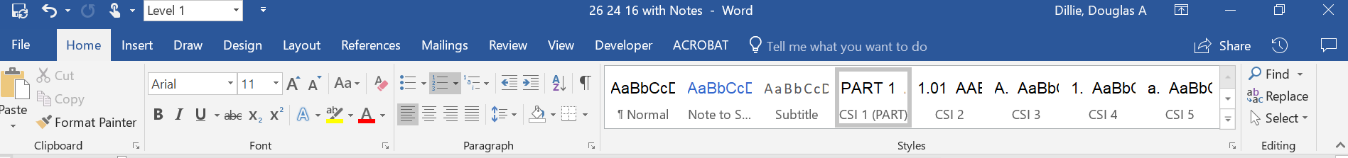

**Review**

“Notes to Specwriter” (when available) are provided using the Reviews feature in Word. To view “Notes to Specwriter” select “All Markup” in the Tracking dropdown menu on the Review ribbon. To hide notes, select “No Markup”. You can advance from one note to the next using the Previous and Next buttons on the same ribbon. In earlier versions of MSWord hide notes by un-checking ‘Comments’ under Review>SH

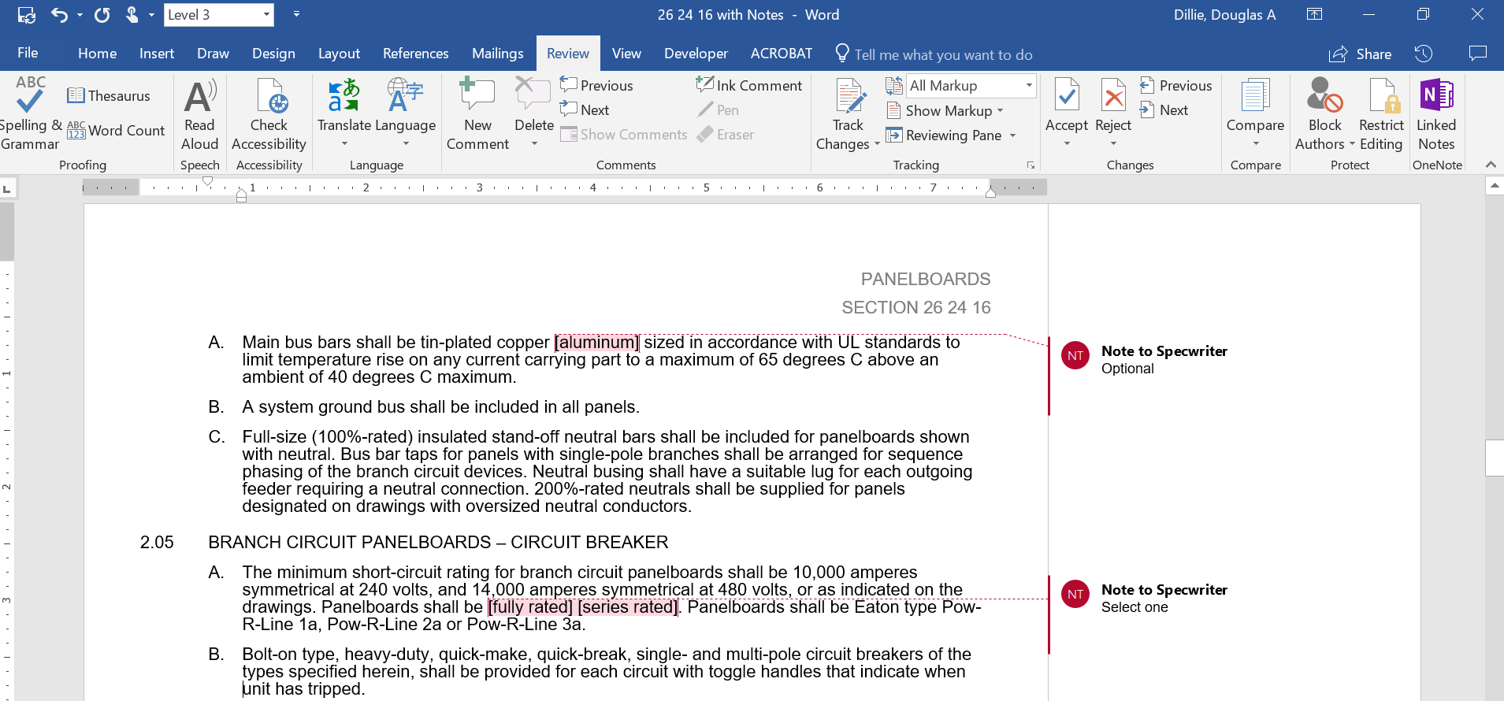

**Outline view**

The Outline view within Word is often helpful when editing or copying sections from this Guide Specification. Also, when pasting sections from this document into a base document the specwriter may want to consider using right-click and “Merge Formatting’ or ‘Keep Text Only” features.

Section 26 24 16.03

Coordination Panelboards

# general

## Scope

### The Contractor shall furnish and install the panelboards as specified and as shown on the contract drawings.

## Related Sections

### Section 16xxx, Fuses

### Section 16671A – Surge Protective Device

## References

### The panelboards and all components shall be designed, manufactured and tested in accordance with the latest applicable standards of NEMA and UL as follows:

#### UL 67 – Panelboards

#### UL 50 – Cabinets and boxes

#### NEMA PB1

#### Fed. Spec. W-P-115C

#### UL98 – Fusible Switches

#### Fusible switch – Type II class I

## Submittals – for Review/approval

### The following information shall be submitted to the Engineer:

#### Chassis layout drawing with dimensions indicated and nameplate designation

#### Component list

#### Conduit entry/exit locations

#### Assembly ratings including:

##### Short-circuit rating

##### Voltage

##### Continuous current

#### Cable terminal sizes

#### Product data sheets

## Submittals – for construction

### The following information shall be submitted for record purposes:

#### Final as-built drawings and information for items listed in Paragraph 1.04, and shall incorporate all changes made during the manufacturing process

#### Installation information

#### Seismic certification and equipment anchorage details as specified

## Qualifications

### The assembly and the major components within the assembly shall be the products of a single manufacturer.

### For the equipment specified herein, the manufacturer shall be ISO 9001 or 9002 certified.

### The manufacturer of this equipment shall have produced similar electrical equipment for a minimum period of five (5) years. When requested by the Engineer, an acceptable list of installations with similar equipment shall be provided demonstrating compliance with this requirement.

### Provide Seismic qualified equipment as follows:

#### The equipment and major components shall be suitable for and certified ***by actual seismic testing*** to meet all applicable seismic requirements of the 2006 International Building Code (IBC). Equipment certification acceptance criteria shall be based upon the ability for the equipment to be returned to service immediately after a seismic event within the above requirements without the need for repairs.

#### The following minimum mounting and installation guidelines shall be met, unless specifically modified by the above referenced standards.

##### The Contractor shall provide equipment anchorage details, coordinated with the equipment mounting provision, prepared and stamped by a licensed civil engineer in the state. Mounting recommendations shall be provided by the manufacturer based upon the above criteriato verify the seismic design of the equipment.

##### The equipment manufacturer shall certify that the equipment can withstand, that is, function following the seismic event, including both vertical and lateral required response spectra as specified in above codes.

##### The equipment manufacturer shall document the requirements necessary for proper seismic mounting of the equipment. Seismic qualification shall be considered achieved when the capability of the equipment, meets or exceeds the specified response spectra.

## Regulatory Requirements

### Panelboard overcurrent protective devices shall be selectively coordinated with all supply side overcurrent protective devices as required for this project by the National Electrical Code/NFPA 70 Articles 645.27, 700.27, 701.27 and 708.54.

### The panelboards shall be UL listed.

## Delivery, Storage and Handling

### Equipment shall be handled and stored in accordance with manufacturer’s instructions. One (1) copy of these instructions shall be included with the equipment at time of shipment.

## Operation and Maintenance Manuals

### Equipment operation and maintenance manuals shall be provided with each assembly shipped and shall include instruction leaflets, instruction bulletins and renewal parts lists where applicable, for the complete assembly and each major component.

# products

## manufacturers

### Eaton

### __________

### __________

The listing of specific manufacturers above does not imply acceptance of their products that do not meet the specified ratings, features and functions. Manufacturers listed above are not relieved from meeting these specifications in their entirety. Products in compliance with the specification and manufactured by others not named will be considered only if pre-approved by the Engineer ten (10) days prior to bid date.

## ratings

### Panelboards shall be fully rated for use in systems up to 600VAC with available short circuit current of 200kA RMS symmetrical. 125VDC panelboards shall be rated for use on systems with available short circuit current of 100kA.

### Panelboard main rating shall be available up to and including 400A.

### Panelboards shall be labeled with a UL short-circuit rating.

## construction

### Interiors shall be completely factory assembled. They shall be designed such that switching units and protective devices can be replaced without disturbing adjacent units and without removing the main bus connectors.

### Trims for branch circuit panelboards shall be supplied with a hinged door over all disconnect handles. Doors in panelboard trims shall not uncover any live parts. Doors shall have a semi flush cylinder lock and catch assembly. Door-in-door trim shall be provided. Both hinged trim and trim door shall utilize three point latching. No tools shall be required to install or remove trim. Trim shall be equipped with a door-actuated trim locking tab. Equip locking tab with provision for a screw such that removal of trim requires a tool, at the owner’s option. Installation shall be tamper resistant with no exposed hardware on the panelboard trim.

### Surface trims shall be same height and width as box. Flush trims shall overlap the box by 3/4 of an inch on all sides.

### A directory card with a clear plastic cover shall be supplied and mounted on the inside of each door.

### All locks shall be keyed alike.

## bus

### Main bus bars shall be [tin-plated aluminum] [copper] sized in accordance with UL standards to limit temperature rise on any current carrying part to a maximum of 65 degrees C above an ambient of 40 degrees C maximum.

### A [system] [insulated/isolated] [system and insulated/isolated] ground bus shall be included in all panels.

### Full-size (100%-rated) insulated neutral bars shall be included for panelboards shown with neutral. Bus bar taps for panels with single-pole branches shall be arranged for sequence phasing of the branch circuit devices. Neutral busing shall have a suitable lug for each outgoing feeder requiring a neutral connection. 200%-rated neutrals shall be supplied for panels designated on drawings with oversized neutral conductors.

## branch circuit Panelboards

### The minimum short-circuit rating for branch circuit panelboards shall be as specified herein or as indicated on the drawings. Panelboards shall be fully rated Panelboards shall be Eaton type Pow-R-Line 3FQS, Bussman Type QSCP, or engineer approved equal.

### Panelboard shall have an integrated spare fuse compartment for up to (6) spare CUBEfuses CUBEFuses as standard.

### Branch circuit disconnecting means shall be bolt-on Bussmann Type CCPB with Bussmann Low-Peak CUBEFuses utilized for overcurrent protection. Ratings shall be available from 15-100A with minimum interrupting rating of 300kA symmetrical and 200kA short circuit current assembly rating.

### Branch circuit devices shall include a non-defeatable interlock to prevent removal of fuse under load. Provide a fuse ampacity rejection feature to prevent overfusing of branch circuits. Fuses shall be indicating type with permanently installed neon indicating light. Branch devices shall be finger-safe when panelboard trim is removed. Provide lockout/tagout provision for each branch circuit position.

## SOLID STATE METERING DEVICES

### Provide solid state metering devices as specified in Section 16901

## surge protective devices

### Provide surge protective devices as specified in Section 16671A.

## enclosure

### Enclosures shall be at least 20 inches wide made from galvanized steel. Provide minimum gutter space in accordance with the National Electrical Code. Where feeder cables supplying the mains of a panel are carried through its box to supply other electrical equipment, the box shall be sized to include the additional required wiring space. At least four interior mounting studs with adjustable nuts shall be provided.

### Enclosures shall be provided with blank ends.

### Where indicated on the drawings, branch circuit panelboards shall be column width type.

## nameplates

### Provide an engraved nameplate for each panel section.

## finish

### Surfaces of the trim assembly shall be properly cleaned, primed, and a finish coat of gray ANSI 61 paint applied.

# execution

## factory testing

### Factory tests shall be performed on the equipment provided under this section. All tests shall be in accordance with the latest version of NEMA and UL standards.

## installation

### The Contractors shall install all equipment per the manufacturer’s recommendations and the contract drawings.