**Eaton Guide Specification**

**Notes and instructions to specwriter**

The following guide specification is offered for your assistance in specifying this product as part of a CSI (Construction Specification Institute) compliant document.

This guide specification has been created in MS Word and uses Word features including **Styles** and **Review** to assist in editing and formatting. You may also find it helpful to view the document in **Outline** mode when editing or selecting sections to copy/paste into your base document.

**Styles**

Styles are provided for all paragraph types described in the CSI Masterformat. Applying a Style to text will provide the correct indentation, paragraph letter/number, font, capitalization, etc…. Styles are shown on the right-hand side of the Word “Home” ribbon.

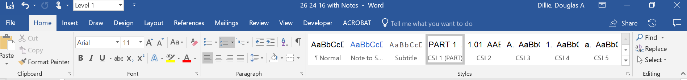

**Review**

“Notes to Specwriter” (when available) are provided using the Reviews feature in Word. To view “Notes to Specwriter” select “All Markup” in the Tracking dropdown menu on the Review ribbon. To hide notes, select “No Markup”. You can advance from one note to the next using the Previous and Next buttons on the same ribbon. In earlier versions of MSWord hide notes by un-checking ‘Comments’ under Review>SH

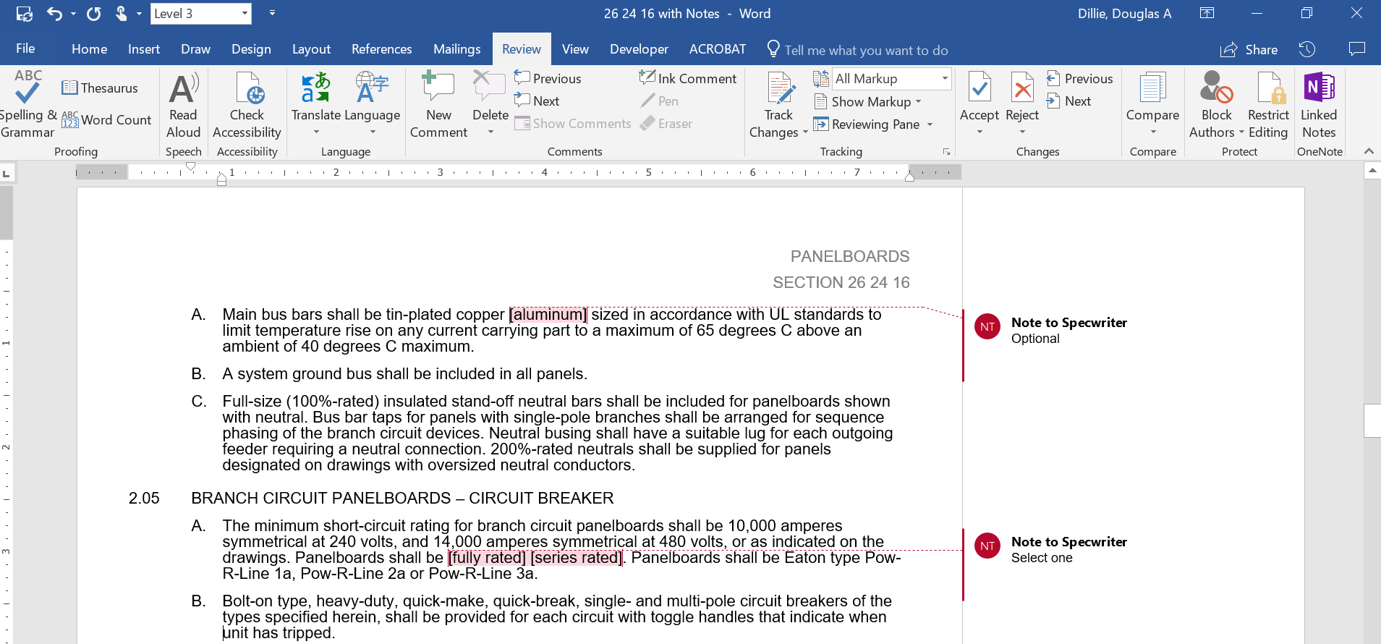

**Outline view**

The Outline view within Word is often helpful when editing or copying sections from this Guide Specification. Also, when pasting sections from this document into a base document the specwriter may want to consider using right-click and “Merge Formatting’ or ‘Keep Text Only” features.

section 26 11 13

primary UNIT SUBSTATIONS – secondary 1000 v and above

# General

## Scope

### The Contractor shall furnish and install the primary unit substation(s) complete from the incoming line terminals to the outgoing line terminals as specified herein and as shown on the contract drawings.

### The primary unit substation shall consist of primary equipment, transformer, and secondary equipment as specified below. The manufacturer of the unit substation shall furnish and coordinate all major components of the substations, including incoming primary equipment section, transformer and low-voltage section, as well as circuit breakers, fusible switches, and metering components. Provide a single warranty covering all substation assemblies, transformers and components.

### Connections between the primary device and transformer shall be [cable] [bus], and between the transformer and secondary shall be flexible bus braid.

### Outdoor primary and secondary equipment, where specified, shall be of weatherproof construction, rodent proof and shall contain 120-volt space heaters, receptacles and lighting as required.

## Related Sections

### Section 26 12 13 – Substation Transformers – Liquid-Filled

### Section 26 12 16 – Substation Transformers – Dry-Type

### Section 26 12 16.17 – Substation Transformers – Resibloc Cast Resin

### Section 26 12 16.15 – Substation Transformers – Vacuum Cast-Coil Design

### Section 26 13 26 – Metal-Clad Switchgear (VacClad-W) – Medium Voltage

### Section 26 13 13.21 – Metal-Enclosed Breaker Switchgear – Medium Voltage Drawout Mounted (MEB)

### Section 26 13 13.23 – Metal-Enclosed Breaker Switchgear – Medium Voltage Fixed Mounted (MSB)

### Section 26 18 39 – Motor Starters (AMPGARD) – Medium Voltage

### Section 26 13 16.13 – Medium Voltage Switches

## References

### The primary unit substation shall be designed, assembled, tested and installed in accordance with latest applicable standards of NEMA, IEEE and ANSI, applicable to its three (3) major sections:

#### MV Metal-Clad Switchgear – NEMA SG4, SG5; ANSI C37

#### MV Metal-Enclosed Switchgear – NEMA SG4, SG5; ANSI C37

#### MV Load Interrupter Switchgear – NEMA SG4, SG5; ANSI C37

#### MV Motor Controllers – ANSI/NEMA ICS-3-Part 2, UL347

#### Primary Substation Transformers – NEMA 201, IEEE 100, ANSI C57

## Submittals – for review/Approval

### The following information shall be submitted to the Engineer:

#### Master drawing index

#### Front view elevation

#### Floor plan

#### Single line

#### Schematic diagram

#### Nameplate schedule

#### Component list

#### Conduit entry/exit locations

#### Assembly ratings including:

##### Short-circuit rating

##### Voltage

##### Continuous current

##### Basic impulse level for equipment over 600 volts

##### kVA

#### Major component ratings including:

##### Voltage

##### Continuous current

##### Interrupting ratings

#### Cable terminal sizes

#### Connection details between close-coupled assemblies

#### Composite front view and floor plan of close-coupled assemblies

#### Impedance for transformers

#### Product data sheets

### Where applicable, the following additional information shall be submitted to the Engineer:

#### Busway connection

#### Key interlock scheme drawing and sequence of operation

## Submittals – for construction

### The following information shall be submitted for record purposes:

#### Final as-built drawings and information for items listed in Paragraph 1.04, and shall incorporate all changes made during the manufacturing process

#### Wiring diagrams

#### Certified production test reports

#### Installation information

#### Seismic certification as specified

## Qualifications

### The manufacturer of the assembly shall be the manufacturer of the major components within the assembly.

### For the equipment specified herein, the manufacturer shall be ISO 9001 or 9002 certified.

### The manufacturer of this equipment shall have produced similar electrical equipment for a minimum period of five (5) years. When requested by the Engineer, an acceptable list of installations with similar equipment shall be provided demonstrating compliance with this requirement.

### Provide Seismic tested equipment as follows:

#### The equipment and major components shall be suitable for and certified by actual seismic testing to meet all applicable seismic requirements of the [latest International Building Code (IBC)] [latest California Building Code (CBC) with OSHPD Amendments]. [The equipment shall have OSHPD Special Seismic Certification (OSP) Pre-Approval.]

#### The Project Structural Engineer will provide site specific ground motion criteria for use by the manufacturer to establish SDS values required.

#### The IP rating of the equipment shall be 1.5

#### The Structural Engineer for the Site will evaluate the SDS values published on the [Manufacturer’s] [OSHPD] website to ascertain that they are "equal to" or "greater than" those required for the Project Site.

#### The following minimum mounting and installation guidelines shall be met, unless specifically modified by the above referenced standards.

##### The Contractor shall provide equipment anchorage details, coordinated with the equipment mounting provision, prepared and stamped by a licensed civil engineer in the state. Mounting recommendations shall be provided by the manufacturer based upon the above criteriato verify the seismic design of the equipment.

##### The equipment manufacturer shall certify that the equipment can withstand, that is, function following the seismic event, including both vertical and lateral required response spectra as specified in above codes.

##### The equipment manufacturer shall document the requirements necessary for proper seismic mounting of the equipment. Seismic qualification shall be considered achieved when the capability of the equipment, meets or exceeds the specified response spectra.

## Regulatory Requirements

### Certified copies of production test reports shall be supplied demonstrating compliance with these standards when requested by the engineer.

## Delivery, Storage and Handling

### Equipment shall be handled and stored in accordance with manufacturer’s instructions. One (1) copy of these instructions shall be included with the equipment at time of shipment.

## Operation and Maintenance Manuals

### Equipment operation and maintenance manuals shall be provided with each assembly shipped and shall include instruction leaflets, instruction bulletins, and renewal parts lists where applicable, for the complete assembly and each major component.

# A Products – Primary equipment

*Note to Spec.Writer:  
Select primary from one of the following guide specifications:

Metal-Clad Switchgear (VacClad-W)

Metal-Enclosed Breaker Switchgear - Drawout Mounted (MEB)

Metal-Enclosed Breaker Switchgear - Fixed Mounted (MSB)  
Medium Voltage Switches (MVS)

# B products – Transformers

**\***Note to Spec. Writer:  
Select transformer from one of the following:

Liquid Transformers   
Dry-Type Transformers   
RESIBLOC® Cast Resin Transformers   
Cast Coil Transformers

# C Products – Secondary equipment

*Note to Spec. Writer:  
Select secondary from one of the following:

Metal-Clad Switchgear (VacClad-W)

Metal-Enclosed Breaker Switchgear - Drawout Mounted (MEB)

Metal-Enclosed Breaker Switchgear - Fixed Mounted (MSB)  
Medium Voltage Switches (MVS)

Motor Starters (AMPGARD)

# execution

## factory testing

### Standard factory tests shall be performed on the primary equipment provided under this section. All tests shall be in accordance with the latest version of ANSI and NEMA standards.

### The following factory tests shall be made on all transformers. All tests shall be in accordance with the latest revision of ANSI and NEMA standards.

#### Resistance measurements of all windings on the rated voltage connection of each unit and at the tap extremes of one unit only of a given rating on this project

#### Ratio tests on the rated voltage connection and on all tap connections

#### Polarity and phase-relation tests on the rated voltage connections

#### No-load loss at rated voltage on the rated voltage connection

#### Exciting current at rated voltage on the rated voltage connection

#### Impedance and load loss at rated current on the rated voltage connection of each unit and on the tap extremes of one unit only of a given rating on this project

#### Applied potential test

#### Induced potential tests

#### Temperature test(s) shall be made on [all units] [one unit only of a project covering one or more units of a given kVA rating]. Tests shall not be required when there is available a record of a temperature test on an essentially duplicate unit. When a transformer is supplied with auxiliary cooling equipment to provide more than one kVA rating, temperature tests as listed above shall be made on the lowest kVA OA or AA rating and the highest kVA FA rating

#### ANSI impulse test on all primary windings

### The following standard factory tests shall be performed on the secondary equipment provided under this section. All tests shall be in accordance with the latest version of ANSI and NEMA standards.

#### The switchgear shall be completely assembled, wired, adjusted and tested at the factory. After assembly, the complete switchgear shall be tested to assure the accuracy of the wiring and the functioning of all equipment. The main bus system shall be given a dielectric test per ANSI standards between live parts and ground and between opposite polarities

#### The wiring and control circuits shall be given a dielectric test of 1500 volts for one minute or 1800 volts for one second between live parts and ground, in accordance with ANSI C37.20.1

### The manufacturer shall provide three (3) certified copies of factory test reports.

### Factory tests as outlined above shall be witnessed by the owner’s representative.

#### The manufacturer shall notify the owner two (2) weeks prior to the date the tests are to be performed

#### The manufacturer shall include the cost of transportation and lodging for up to three (3) owner’s representatives. The cost of meals and incidental expenses shall be the owner’s responsibility

## field quality control

### Provide the services of a qualified factory-trained manufacturer’s representative to assist the Contractor startup of the equipment specified under this section for a period of ________ working days.

### The Contractor shall provide three (3) copies of the manufacturer’s field startup report.

## training

### The Contractor shall provide a training session for up to five (5) owner’s representatives for _____ normal workdays at a job site location determined by the owner.

### The training session shall be conducted by a manufacturer’s qualified representative. The training program shall include instructions on the assembly including primary equipment, transformer and secondary equipment. All circuit breakers, protective devices and other major components shall be included.

## installation

### The Contractors shall install all equipment per the manufacturer’s recommendations and the contract drawings.

### All necessary hardware to secure the assembly in place shall be provided by the Contractor.

## field adjustments

## Field Testing